
Phgy 312
Set #11
lecture #: | date: | professor:
32  33  34 | March 28, 2007  March 30, 2007  April 2, 2007 | Dr. Mortola  Dr. Mortola  Dr. Mortola

announcements:
- I will be adding other lectures to this set as I get them from the editors.

Edited by: Aradhana Persad and Tiffany Chan
Do Not Redistribute.
PHGY 312 – Lecture 32 March 28, 2007
Writer: Laura Robinson Dr. Mortola

Topics Covered in the Last Lecture
- Ventilation-perfusion ratio.
  - This is a very important topic because it illustrates what respiratory function is all about.
- O₂ and CO₂ transport in the blood.
  - O₂ physically dissolved.
  - O₂ bound to haemoglobin.
  - Haldane effect: a change in hemoglobin at the level of the lung. High oxygen pressures enhance the unloading of CO₂ from hemoglobin.
  - Bohr effect: an increase in blood carbon dioxide level, a decrease in pH or increased temperature causes hemoglobin to bind to oxygen with less affinity, or the PO₂ curve is shifted to the right.
- Factors shifting the PO₂-O₂ curve and the PCO₂-CO₂ curve.
- Partial Pressures of O₂ and CO₂ (inspired, alveolar, arterial and venous).
- In the venous blood, the total pressure is below atmospheric which allows our circulatory system to absorb gas wherever it may be.

Practice Questions
A) During anemia:
- PaO₂ decreases
- O₂ saturation of the blood decreases
- O₂ content of the blood decreases

  - Anemia is a decrease in the number of erythrocytes which can be due to many reasons (congenital, blood loss, etc.).
  - Erythrocytes are the carriers of the hemoglobin.
  - During anemia, there is a mismatch between pressure and content. This has to do to with the S-shape of the hemoglobin-dissociation curve.
  - Option 1 is incorrect. A drop in haemoglobin will not cause a change in PO₂
- This is a result of equilibration including plasma, tissue and blood.
- Even if you lost all your blood and were transfused with saline/water, the partial pressure of the water will be in equilibrium with your alveoli. The PO₂ would be normal.
- It is the content that would decrease since there would be less hemoglobin.
- Option 2 is incorrect. If we have a normal PaO₂, the saturation will be normal.
- Option 3 is correct. We don’t have our carrier, haemoglobin, and therefore the only oxygen we can count on is what is physically dissolved (a very small amount).

B) In mixed venous blood during severe hypoxia:
    - PO₂ is almost zero.
    - PCO₂ exceeds 60 mm Hg.
    - Partial pressure of water is less than in the arterial blood.
    - Total pressure is approximately atmospheric pressure.

- Mixed venous blood is the blood that is collected by the right atrium.
- Option 1 is incorrect. Even if we are dying from hypoxia, there is still a substantial amount of oxygen in our blood.
        - It is impossible to withdraw all the oxygen from the blood.
        - The reason one might die under these conditions would be because there is not enough PO₂ to drive oxygen into the mitochondria.
- Option 2 is incorrect. If a person is hypoxic, you increase ventilation to bring oxygen in therefore hyperventilation reduces CO₂.
- Option 3 is incorrect. We are talking about a fluid.
        - Whether we are talking about venous or arterial blood, it will always be fully saturated at physiological temperature (37°C). The water vapour saturation is 47 mm Hg.
        - Whether we are under hypoxic or hyperoxic conditions, it doesn’t matter. As long as we are examining both venous and arterial blood under the same given temperature, they will both be fully saturated with water.
- Option 4 is incorrect. The total pressure in the venous blood is below atmospheric.

CONTROL OF RESPIRATION

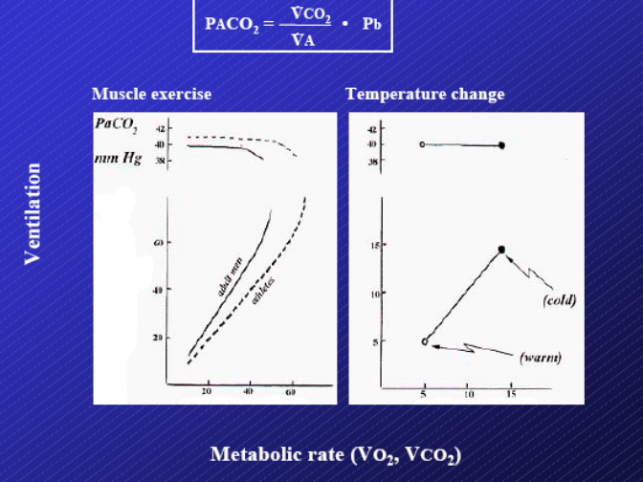
Why do we breathe the amount that we do?
- It is based on our metabolic demand, but how does the body know our metabolic demand and how does it know how much air to pump to fulfill it?
- Refer to the left graph – when metabolic rate increases as a result of exercise (cold stimulus), ventilation increases in parallel.
- But you’ll also notice that PaCO₂ remains constant.
- Because this is held constant – we know that VCO₂ and VA match perfectly.
- It also means that the increase in ventilation cannot be driven by a change in PCO₂ because it is constant.
- And PaO₂ is also fixed – yet ventilation still increases.
- So how does your body know about metabolism?

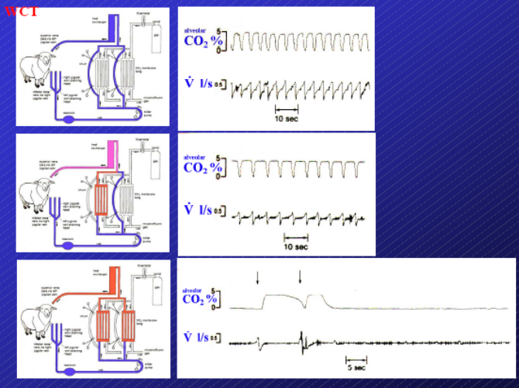
Sheep Experiment
- All the blood going to the right heart has been bypassed by a device. The blood is not passing through the lungs.
- The machinery acts like the lung, exchanging CO₂ for O₂.
- The blood is then put back into the superior vena cava (SVC), essentially where it was taken from. The blood is then allowed to continue its normal pattern of flow.
- The machine determines the oxygenation of the blood (it can be set).
- In the first graph, the machine is not working. The blood is just running along the external pathway created by the machine and then is emptied into the SVC.
- Therefore the sheep is ventilating to compensate for the non-functional machine.
- Once the machine begins to work, ventilation rate begins to decrease.
- The bottom graph shows a working machine that allows the gas pressures to be changed to what they would become in the lung (100 mm Hg for oxygen, 40 mm Hg for CO₂).
- When the machine does this, the sheep stops breathing.
- The arrows indicate the experimenters pinching the sheep to make sure they are still capable of breathing.
- This experiment lasted for an hour.
- The machinery is doing the exchanging for the sheep.
- However, the blood that is returned to the sheep is not rich in oxygen and is not poor in CO₂.
- Therefore this experiment demonstrates that if you are able to get rid of what you metabolically produce, you don’t need to breathe. Ventilatory control is very sensitive to metabolism.

Take Home Message: This experiment reinforced that we only breathe enough to fulfill our metabolic requirements or to get rid of what we produce metabolically. In the first two cases, the sheep’s metabolic needs were not being met by the machine so it had to breathe. The O₂ added was inadequate and not enough CO₂ was removed from the blood. The sheep stopped breathing in the last case because enough CO₂ was removed and enough O₂ was added to fulfill metabolic requirements.
NEURAL CONTROL OF RESPIRATION
- The next question is: where are the metabolic receptors? How does the body know that some machinery in the body is taking care of our metabolic needs?
- First of all, where is respiratory activity generated?
- With the heart, as long it is provided with glucose and oxygen, it will continue to beat because of the presence of pacemaker cells.
- Unlike the heart, the lungs do not have pacemaker cells.
- Most people are looking for a respiratory control center in the medulla oblongata.
- If you were to section the upper brainstem and take away the cerebral hemispheres, nothing happens.
- Whatever is above the pons is irrelevant for the generation of breathing activity.

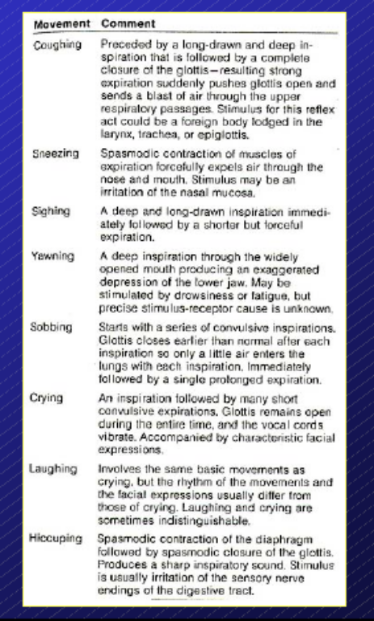
Cortex and Limbic System
- Both have voluntary influences on breathing.
  - There are many acts that are voluntary or semi-voluntary that are important because they are integrated with respiratory function.
  - You can control how much you breathe in by keeping your abdominal muscles at a certain length, for example, to generate more force.
  - You can prevent yourself from breathing until the chemical autonomic stimuli prevails.
  - Coughing can be an automatic response, but can also be stimulated.
  - Note that sometimes laughing and crying are indistinguishable. From a physiological perspective, it is questioned as to why we laugh when we are happy, and don’t have some other reaction.
  - Emotions can trigger an increase in cardiac output, which has a tendency to promote edema – fluid in the alveoli.
  - Some scientists think that we laugh or cry during an emotional event to increase alveolar pressure to counteract the edema which will force fluid back into the vascular bed.
  - Therefore, laughing and crying could be protective mechanisms for the lungs.

Segmentation Experiment
- Segmentation studies have been done for the last 100 years on anesthetized cats.
- If you section between the pons and the medulla, the breathing pattern changes. It becomes erratic.
- It is believed that the nucleus parabrachialus (NPBL) contained within the pons affects the way that lower centres in the brain operate.
- When you cut between the spinal cord and medulla, respiration stops.
- Therefore researchers have been searching this area for years looking for pacemaker cells because it seems that generation of respiration occurs in this area.
- They postulate that many cells are interacting to produce a respiratory network.
- We will look at three types of these cells in the nuclei called the ventral and dorsal respiratory group.

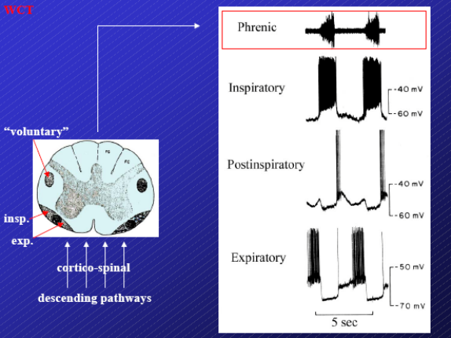
Respiratory Pattern Generator
- The phrenic nerve can be used as a reference when studying respiration to determine when an animal is breathing in or out. You can use it as a reference for whatever you are recording in the nuclei.
- You will find three types of cells related to breathing pattern generation:
    - Strictly inspiratory
    - Strictly expiratory
    - Post inspiratory
- If all these types of cells are put together in a model, and they’re connected in the correct manner, a network can be created that is capable of generating a constant pattern.
- Once this pattern is generated, it needs to go from the medulla to the diaphragm and intercostal muscles.

- There are two pathways connecting the respiratory generator to the motor neurons (phrenic, thoracic and intercostal muscle motor neurons).
    - Autonomic control – located more ventrally in the spinal cord.
    - Voluntary control – located more laterally in the spinal cord.
- Dyspnea – to be aware of the sensation of breathing (you are conscious of the autonomic control of breathing).
  - This also occurs in normal individuals, but only for short periods of time.
  - In cases of dyspnea, it lasts for an extended period of time.
- That disease then implies that it is possible to lesion one pathway while leaving the other pathway intact (this occurs with a rare bilateral tumor).
- If you lesion the voluntary pathway, your ability to breathe normally is intact.
  - However, you cannot control voluntary respiratory acts.
  - For example, you can cough through a reflex but you cannot force yourself cough.
- If you lesion the autonomic pathway, you are forced to think in order to breathe.
  - If you forget about breathing then you don’t contract your respiratory muscles and you stop breathing (referred to as Ondine syndrome, which is very rare).
  - People affected by the syndrome can’t fall asleep because they don’t have any autonomic control of respiration and so they will stop breathing when they fall asleep.
  - Patients must use an external ventilator when they are sleeping.
- In summary, the medulla generates a respiratory pattern which activates the motor neurons. The respiratory muscles will then generate pressure according to their intrinsic characteristics (force-length and force-velocity relationships). This pressure will then translate into ventilation according to the mechanics and characteristics of the respiratory system (compliance and resistance).

Take Home Message: The respiratory pattern generator is comprised of 3 types of cells – inspiratory, expiratory and post-inspiratory. Control exerted by the pattern generator is involuntary and voluntary. There are two different pathways for each: autonomic control is located ventrally and voluntary control is located laterally in the spinal cord. The autonomic pathway must be intact for a person to function normally. Without this pathway, you would have to constantly think about breathing or you would stop breathing. Normal breathing is still maintained without the voluntary pathway.

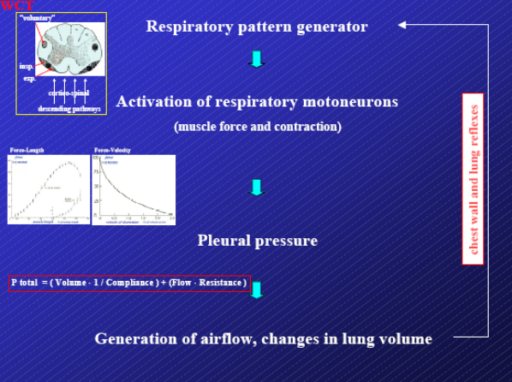
Feedback Systems
- There are a variety of feedback systems that inform the pattern generator on the output of an action such as contracting the diaphragm.
- A feedback system can be generated in two ways:
  - Put receptors on the chest wall.
  - Put receptors in the lungs.
- Throughout evolution, these two major sets of receptors have been found in the lungs and chest.
- Potentially, they could have completed the same task of providing feedback for the pattern generator.
- However, with further evolution, these two pathways diverged and chest wall receptors were created in some animals to regulate breathing according to normal respiratory function.
  - For example during locomotion. The body must integrate breathing with locomotion.
  - The respiratory generator must be informed of what the body is doing to create a pattern that matches the respiratory need of the actions of the body.
- It is the vagus (X) nerve that innervates the thorax.
- Information must be sent from the receptors through afferent neurons to the brain.
- These feedback loops are crucial but there are also many other feedback loops to the respiratory pattern generator that are important.
- Everything from pain to temperature will eventually have an effect on respiration.

- The area from the oropharynx to nasopharynx is extremely important in breathing.
- Almost all functions completed in this area are done autonomically.
- The integration of these two areas is crucial.
- The beginning of this pathway involving this area is common to the functions of digestion and respiration.
- Therefore there must be an enormous amount of integration so that both functions can occur without “stepping on each other’s toes.”
- Larynx moves up and down as we swallow.
- Moving the larynx up and closing the glottis when swallowing needs lots of afferent and efferent integration to prevent food from entering the trachea.
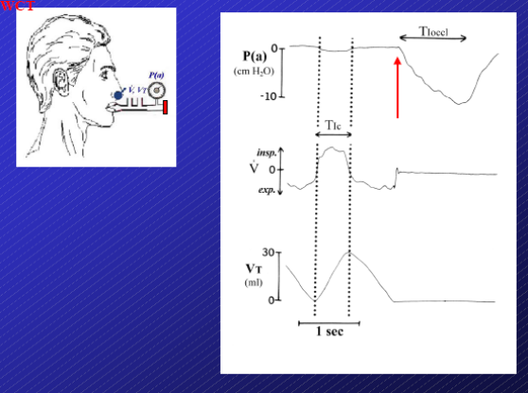
Respiration Experiment
- The subject breathes into the apparatus and we can measure flow, volume and pressure of the mouth.
- The pressure of the mouth during breathing is around zero.

Occlusion at the End of Expiration
- If the breathing tube is occluded at the end of expiration without the subject being aware of it:
- They will try to continue breathing normally, but cannot breathe in because of the occlusion.
- The lung volume doesn’t change, but the subject creates a negative pressure (inspiratory effort).
- The point of this exercise is to show that the duration of this effort is longer than the normal inspiratory time.
- Note that this experiment can be done in an unconscious subject. This response is not constant because the subject is panicking for air.
- The pressure developed depends on the force-length relationship.
- If you don’t change the volume of the lungs, such as in this case, then the inspiratory muscles can generate more force due to the force-length relationship.
- The pressure generated is not due to the duration of the effort. The duration of the effort is longer than the respiratory function.
- If we don’t allow the lungs to inflate, then the respiratory centres fire for a longer period of time.
- This is to say that when the lungs are allowed to inflate, something stops the inspiratory time.
Note: We will continue to discuss this later in the lecture.
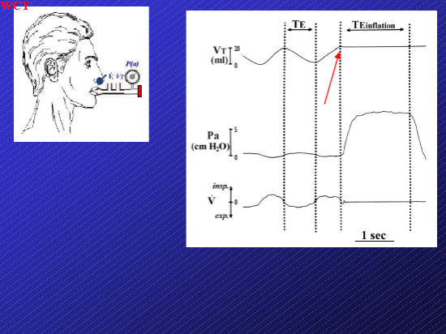
Occlusion at the End of Inspiration
- If the breathing tube is occluded at the end of inspiration, then the subject can no longer breathe out.
- How long will the subject wait until taking the next breath?
- They will wait much longer than the normal expiratory time.
- Why is the system delayed?
- The lungs are now inflated and something is telling the system not to breathe, just like in the previous occlusion experiment, when something was telling the system to breathe.

Vagus Nerve
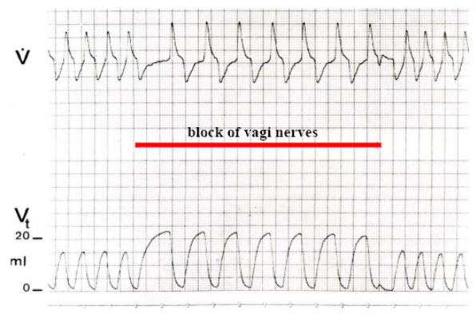
- In this next experiment, the vagus nerve is cut in an animal breathing normally.
- However, scientists don’t usually like to cut the vagus so it is actually blocked by various methods (pharmacologically, temperature, etc.).
- By blocking the vagus you are stopping the afferent traffic from the lungs to the respiratory centre.
- The breathing of the animal then becomes deep and slow.
- We have eliminated a peripheral input which was inhibitory.
- When breathing is stopped at the end of expiration (occlude the breathing tube at the end of expiration) there is no inhibition therefore the time of inspiration is longer.
- When we stop breathing at the end of inspiration, there is an enormous amount of inhibition therefore the time before the next breath is taken is extended.
- If we take away the afferents – respiration lasts for an even longer amount of time.
- This leads us to the conclusion that there is something from the lungs telling the respiratory centers to stop firing.

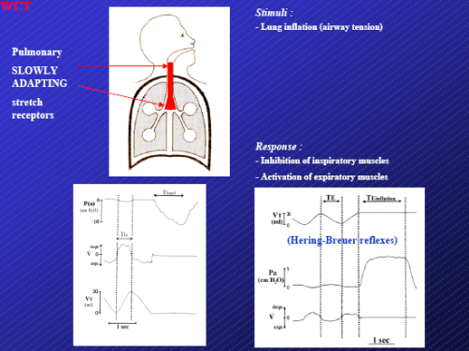
Slowly Adapting Stretch Receptors
- If lung inflation is maintained, these receptors continue to fire and adapt extremely slowly.
- These receptors are located in the large airways.
- Their stimulus is lung inflation or tension and their response is inhibition of inspiration.
- They inhibit inspiratory muscles and activate expiratory muscles.
- These reflexes are referred to as the Hering-Breuer reflexes.
- When these receptors are not activated because lung volume stays at zero, the respiratory output will be longer.
- However, when they are activated, the next breath will be delayed through an inhibitory effect on the respiration center.
- If the vagus is blocked, then respiration will be deeper.

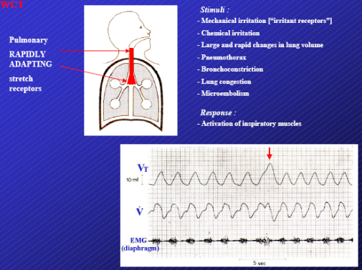
Rapidly Adapting Stretch Receptors (Irritant Receptors)
- If we increase lung volume, they adapt quickly.
- These receptors are also found in the large airways.
- They respond to a large number of stimuli.
  - The common factors seen in all the different stimuli are local irritation or a decrease in lung compliance.
- When lung compliance decreases or there are irritants in the airways, the receptors are activated.
- The response produced by the receptors is to activate the inspiratory muscles to produce a deep breath.
- A deep breath is a natural way to respond to a drop in compliance.
- These receptors are part of a defence mechanism for keeping the lungs open.

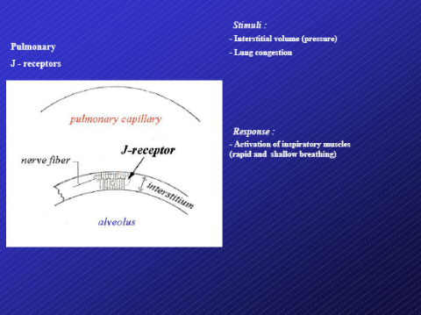
J-Receptors
- In reality these receptors are just free endings.
- They are located in the lung interstitium between the vascular part and the alveolar part.
- Stimulated when the pressure in the interstitium increases (for example, when cardiac output increases).
- Their response is to produce rapid and shallow breathing.
- These receptors seem to be important in controlling breathing during muscle exercise.
Note: We will discuss these receptors during exercise in a later lecture.

PHGY 312 – Lecture 33 March 30, 2007
Writer: Roni Wisehart Dr. Mortola

Topics Covered in the Last Lecture
- Experiment with sheep and external gas-exchanger.
- The coupling between metabolism and ventilation.
- Respiratory pattern generation:
  - The cortex is very involved in determining the way in which we breathe.
  - The generation of the respiratory pattern is in a very tiny region of the medulla, with the pons providing some inhibitory input to the medulla.
  - There are three key elements to generating a respiratory network: inspiratory, expiratory and post-inspiratory neurons.
- The descending pathways are peculiar in breathing because they have different routes for autonomic (involuntary) and voluntary control.
- There are many feedback loops for the respiratory pattern generator.
  - For example, distension of the abdominal viscera can create ventilatory responses that are maladaptive.
  - The only feedback loops mentioned in class involved the upper airways.
- The larynx in an organ which has a lot of afferent innervation which make neuronal endings that send information to the brain stem regarding pressure, temperature, tension, flow, etc. All these types of stimuli may or may not occur at the same time.
  - Some of these factors have been attributed as causative events for SIDS (crib death).
  - Therefore the larynx is a strong reflexogenic area that impinges on many aspects of homeostasis and respiration.
- Vagal control of the breathing pattern.
- Hering-Breuer reflexes.
- Airway receptors:
  - The slowly adapting receptors are controlled by lung volume, tension and pressure. They fire when there is an increase in lung volume.
  - The rapidly adapting receptors are also stretch receptors but they adapt quickly to stimuli and are mainly involved in defense mechanisms. They promote inspiration.
  - The J-receptors are non-myelinated fibers therefore their conduction velocity is low. They respond mostly to tension and stretch but in the interstitium between the alveoli and capillaries.
  - This space must be very thin to promote effective and efficient exchange of gases.
  - In the case of exercise, the interstitial space is likely to increase in size due to an increase in cardiac output. This causes the pulmonary pressure to increase resulting in pulmonary edema.
  - With an increased amount of water in the space, there is a stretch of the walls causing the J-receptors to be activated to produce a rapid and shallow breathing pattern.
Note: We will discuss the J-receptors further in the lecture on exercise.

Review Questions

Note: Correct answers are in bold.

- The prolongation of inspiratory time during airway occlusion at the end of expiration is due to:
  - Intrinsic mechanical properties of the respiratory muscles
  - Activation of the rapidly adapting airway receptors
  - Lack of activation of the slowly adapting airway receptors
    - A stronger pressure is developed because the muscles are kept stressed therefore the force is greater (whenever the length is greater, the force produced is greater).
    - Because the occlusion is at the end of expiration, when the subject tries to breathe in, the diaphragm and the intercostal muscles cannot shorten. Therefore the long length of the muscles is maintained thus generating a greater force.
    - This however, is not responsible for the prolongation of the inspiratory time. It simply generates a larger force thus A is incorrect.
    - Activation of the rapidly adapting receptors could promote a longer inspiratory time, but there is no increase in lung volume to activate the receptors therefore B is also incorrect.
    - A lack of activation of the slowly adapting receptors could certainly prolong the inspiratory time. If lung volume doesn’t change, there is no progressive inhibition coming from the lungs. The inspiratory output can then last longer therefore C is correct.

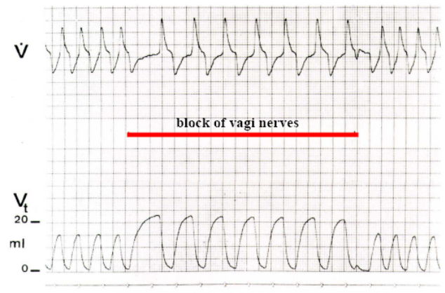
- After a bilateral section of vagal pulmonary afferent, you would expect:
  - A drop in alveolar ventilation
  - A drop in arterial PCO₂
  - A greater frequency of periodic deep breaths

    - A bilateral section of the vagal pulmonary afferent more or less refers to the experiment from the last lecture where the vagi nerves were blocked to produce slow and deep breaths.
- By removing vagal inhibition from the lung, the respiratory centres in the brain continue to fire resulting in an increase in the tidal volume. The centres are not being inhibited by the afferents coming from the slowly adapting stretch receptors.
- There is still a limitation to the tidal volume which is due to inhibition by the nucleus parabrachialus (NPBL) which is in the pons, on the respiratory centre. However, inhibition by the NPBL occurs well after inhibition produced by the slowly adapting stretch receptors has taken place.
- Therefore ventilation continues thereby increasing tidal volume because of a lack of inhibition by the vagi, but ventilation eventually stops because of inhibition coming from the pons.
- In order to produce a greater frequency of periodic deep breaths, the rapidly adapting receptors must be activated. However, if the vagi are cut, all the afferents have been removed (slowly adapting receptors, rapidly adapting receptors and the J-receptors).
- The rapidly adapting receptors provoke deep breaths whenever lung compliance decreases but we would expect a lower frequency of deep breaths, not a higher frequency. Thus C is incorrect.
- If you look at the breathing pattern, the breaths are becoming deeper and slower. Ventilation (which is the product of tidal volume and frequency) may not change that much. Pulmonary ventilation may be more or less intact.
- However, when we breathe deep and slow, alveolar ventilation will increase because the dead space remains the same. Therefore, even if pulmonary ventilation is unaffected, because we are breathing deep, this would improve alveolar ventilation as long as the frequency is not too low. Therefore A is incorrect.
- If alveolar ventilation increases, then PaCO₂ should decrease (PACO₂ = PaCO₂/alveolar ventilation). Therefore B is correct.

- A rapid lung inflation:
  - Stimulates slowly adapting stretch receptors
  - Stimulates rapidly adapting stretch receptors
  - Results in, at first, activation, then inhibition of breathing

- Whether the inflation is slow or rapid, if we inflate the lung, the slowly adapting stretch receptors will be stimulated and there is an inhibition of breathing thus A is correct.
- By inflating the lung, the rapidly adapting stretch receptors are also stimulated which will promote inspiration therefore B is correct.
- Because both types of receptors are activated, they will produce a pattern of activation then inhibition of breathing.
  - The rapidly adapting receptors act first to promote inspiration, but they will quickly adapt and stop firing.
  - Then the slowly adapting receptors take over and produce an inhibitory response that delays the next breath.
  - Therefore C is also correct.

- This pattern of activation then inhibition of breathing is exemplified in rabbits.
- An adult rabbit has a very compliant belly/chest.
- When the rabbit is in an upright position (standing), the viscera will be pulled down by gravity. The viscera are allowed to move downwards because of the compliant belly. This will then pull down the diaphragm also.
- This will lead to an increase in FRC. This can also be seen in babies.
- If FRC increases the slowly adapting receptors and the rapidly adapting receptors should be activated.
- At first there is a breath due to activation by the rapidly adapting receptors then there is inhibition due to the slowly adapting stretch receptors. This is due to the Hering-Breuer inspiratory inhibitory reflex due to stretch receptor activation.
- If the rabbit continues to stay in the upright position, it will eventually take a breath. This is due to the chemical drive (an increase in CO₂ and a decrease in O₂ in the blood) that offsets the inhibition from the receptors.

- This early response was not understood at first. People expected that there would only be inhibition. It is now understood that as a result of the activation of these reflexes and it’s called Head’s Paradoxical Reflex.
- This is considered an important factor in the onset of breathing at birth. At birth, as soon as the lungs are expanded, there is an additional favoring input on the respiratory centres provided by the rapid activation of the rapidly adapting receptors.
- What you know so far: the Hering-Breuer inhibitory reflex, the Hering-Breuer expiratory promoting reflex and Head’s Paradoxical Reflex (sudden stimulation of the respiratory output as a result of activation of the rapidly adapting receptors).

NEURAL AND CHEMICAL CONTROL OF RESPIRATION

The Tick
- The tick is an interesting invertebrate because they breathe in a way that is very different from humans.
- They have many little tubes leading from the surface of their body to the inside, which are called tracheli.
- These tubes eventually reach the innermost cells of the tick to bring air into contact with the cells. They also have some circulation (lymphatic circulation, but not much) but they rely mainly on the diffusion of air from the surface of their body to their cells.
- When they are flying, they couple convection to diffusion.
- This information is important in terms of hypoxia. When they are exposed to hypoxic conditions, they open spiracles (sphincters on the body surface) to allow for more air flow into their body.
- If these sphincters allow for more air flow, then why aren’t they open all the time? Because this would cause them to lose more water, which is a key substance to life, especially when you are very small in size.
- Under normal conditions, some of the spiracles are open.
- The same type of philosophy in ticks applies to all mammals or air-breathers. You will not increase breathing in hypoxia unless you’re forced to.

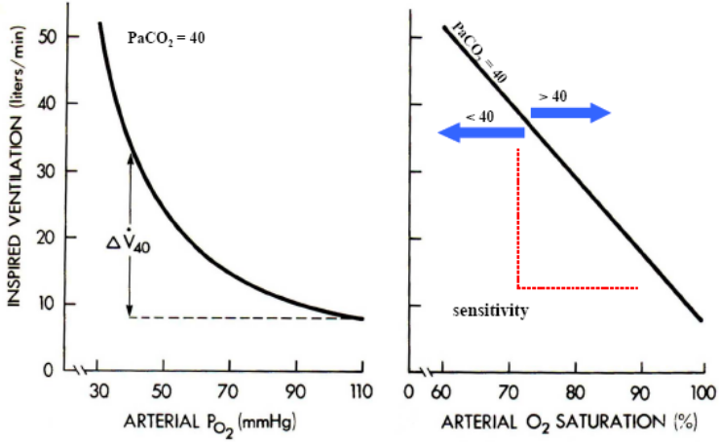
Human Response to Hypoxia
- From the left graph (ventilation vs. PaO₂), it is observed that when PaO₂ decreases, ventilation does not increase that much.
- The basic response occurs when PaO₂ decreases below 70 mmHg. We want to conserve energy, so we don’t respond to a decreased PaO₂ until we absolutely have to.
- Why can we resist from responding until the PaO₂ has reached below 70 mmHg?
- This is because hemoglobin can retain its full saturation of O₂ up to a PaO₂ of 70 mmHg.
- There may be a phylogenetic/evolutionary link between the shape of the hemoglobin dissociation curve and the shape of the curve for the ventilatory response to hypoxia.
- This means that instead of plotting ventilation as a function of PaO₂, ventilation should be plotted as a function of arterial O₂ saturation because both ventilation and saturation do not change until a PaO₂ of 70 mmHg is reached. This produces a linear relationship (refer to the right graph – ventilation vs. arterial O₂ saturation).
- The slope of the line gives the sensitivity to hypoxia. If the slope is very steep, this means that there is a high sensitivity to hypoxia. A small drop in saturation would cause hyperventilation.
- This particular graph is represented at a PaCO₂ of 40 mmHg. This is crucial because PaCO₂ has a lot to do with the sensitivity to hypoxia.
  - If PaCO₂ increases, then the slope increases.
  - If PaCO₂ decreases, then the slope decreases.
  - This is an interaction that occurs at the level of the carotid bodies – the real sensors for hypoxia.
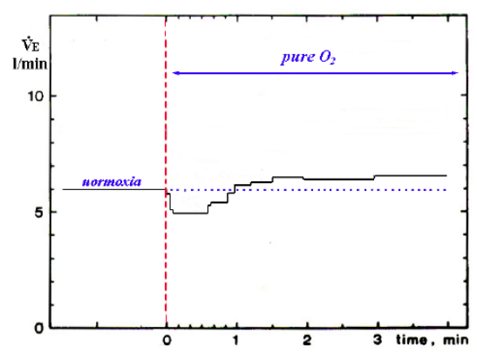
  - If we are hypoxic and hypercapnic (CO₂ increases), we ventilate substantially more.

Ventilation Response to Hyperoxia
    - At rest, in normoxia, we ventilate approximately 5-6 L/min. If we were under hyperoxic conditions, then we would ventilate even less.
    - Refer to the graph on the right: the dashed red line indicates when the subject is under hyperoxic (100% pure O₂) conditions.
    - It is observed that ventilation decreases under hyperoxia. However, ventilation does not cease. There is still a metabolic drive (CO₂) to ventilate.
    - If the hyperoxia is maintained for more than a minute or two, ventilation starts to increase and in fact, increases above the normoxic level of ventilation.
    - It increases because eventually the O₂ saturates the hemoglobin to the point where CO₂ cannot be transported, which drives ventilation (metabolic drive).
    - Therefore, breathing pure O₂ is advantageous for the transport of O₂ but has a large disadvantage in terms of CO₂ transport.

    - If this same experiment were started from hypoxia, ventilation would start at a higher level (8.5 L/min).
    - The subject is then exposed to hyperoxia. Ventilation decreases to the minimum level of ventilation that occurs when the body is saturated with O₂.
    - There is a larger decrease in ventilation in this case as opposed to starting at normoxia because the initial ventilation rate is higher under hypoxia.

    - This type of test is sometimes used to determine the normal ventilatory drive at rest.
    - If the drop in ventilation is large when the subject is exposed to hyperoxic conditions, this means that the subject had a larger metabolic drive under normoxic conditions.
    - Just by looking at how much ventilation decreases when exposed to hyperoxia, you can tell if the subject was hypoxic to begin with. A hypoxic subject would have a greater drop in ventilation than a normoxic subject.
    - For example, if we were to perform this test at a higher altitude and in Montreal, then the drop in ventilation would be greater when the experiment is performed at the higher altitude.

Take Home Message: Ventilation rate decreases when a subject is exposed to hyperoxic conditions, however, the amount that it decreases is dependent upon whether they begin at normoxia or hypoxia. In both cases, ventilation will decrease to the same level. Therefore if they start at hypoxia, the decrease in ventilation is larger because they begin at a higher rate of ventilation than in normoxia.

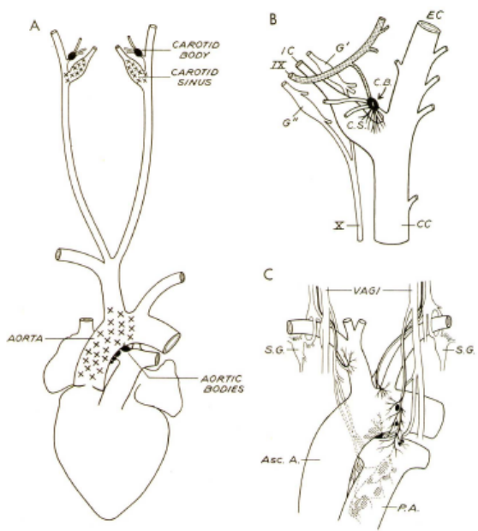
Carotid Bodies
    - The responses observed in the hyperoxia experiments are mediated by the carotid bodies.
    - They are very small structures located at the bifurcation of the common carotid artery.
    - They are located in both the external and internal branches.
    - They are very close to the carotid sinus (responsible for blood pressure regulation). Therefore the nerve carrying information from these two structures could be the same – the glossopharyngeal (IX) nerve.
    - The glossopharyngeal nerve ends in the medulla oblongata, which is very close to the vagus and therefore in close proximity to the respiratory centre.
    - In the diagram, there are also other receptors indicated, namely peripheral chemoreceptors in the aortic arch. In humans, they do not play a large role. They are more important in other species. Only the carotid bodies are crucial in humans.

Experiment
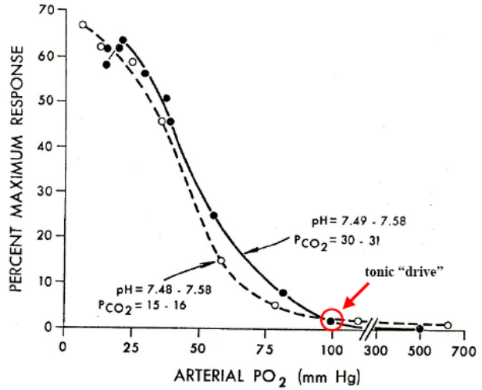
    - An experiment can be done with an animal to measure the firing rate coming from the carotid bodies at different PaO₂ levels.
    - Electrodes are attached to the peripheral cut end of the nerve of the carotid body.
    - Refer to the graph on the right:
  - X-axis – PaO₂
  - Y-axis – activity of the carotid body/percent maximum response/firing rate
- This graph is similar to the graph for the ventilatory response to hypoxia.
- The firing rate response of the carotid body to hypoxia is curvilinear, making the ventilatory response curve curvilinear also.
- As can be seen from the graph, the carotid bodies begin to fire strongly when the PaO₂ goes below 70-75 mmHg, just like the ventilatory response.
- PCO₂ and pH must also be controlled in this case. They are very involved with the firing rate of the bodies, just like they are involved with the ventilatory response.

- Is it possible to change PCO₂ without changing pH?
- It is known that if you increase CO₂, the pH decreases. This will occur unless you change the bicarbonate concentration.
Recall: the Henderson-Hasselbalch equation we learned in Renal Physiology.

- If bicarbonate is changed in proportion to PCO₂, then the pH will not change (refer to the dotted line on the graph).
- Then nothing happens. The PCO₂ is now half its original value but the pH is the same due to the concurrent change in bicarbonate. The two curves are remarkably similar.
- This tells us that the carotid bodies respond to hypoxia and also CO₂ levels because there is a change in pH due to a change in CO₂.
- If there is no change in pH with a change in PCO₂, then the carotid bodies will not change their firing activity.

- There are individuals that have a high PCO₂, like the COPD patient discussed in a previous lecture.
- Because this patient has difficulty in expiring, there tends to be retention of CO₂ in the body.
- Since this is a chronic process, the patient most likely has compensated acidosis, meaning that there is also an increase in bicarbonate along with the CO₂ increase.
- Therefore there is no change in pH and the level of activity of the carotid bodies does not increase.

- Under normal circumstances, the activity of the carotid bodies is not zero. They have some tonic activity.
- If there is an increase in PO₂, then the activity of the carotid bodies decreases, resulting in a decrease in ventilation.

Take Home Message: The carotid bodies have a basal firing rate which changes in response to changing O₂ levels, and to an extent, CO₂ levels. However, the carotid bodies will only respond to CO₂ when there is a subsequent change in pH. If there is a change in CO₂ without a change in pH, the carotid bodies will not change their firing rate.
- What about CO₂? We have seen the response to hypoxia and that the relationship is curvilinear. We have seen that it is similar to the hemoglobin dissociation curve. What about the ventilatory response to increasing CO₂?

Ventilatory Response to CO₂ (Hypercapnia)
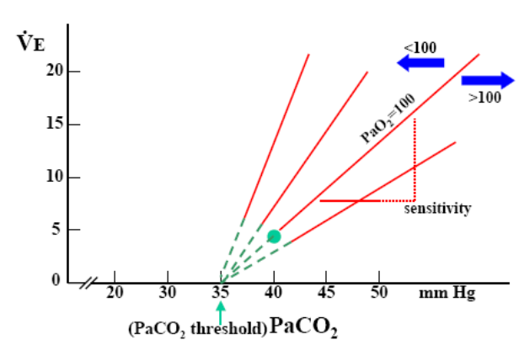
- The ventilatory response to CO₂ is linear, as shown by the graph to the right.
- The slope of the line is sensitivity.
- There is a high sensitivity to oxygen therefore the slope will change with changing levels of O₂.
- When PaO₂ is decreased below 100 mmHg, the slope of the line will increase. If the PaO₂ is increased above 100 mmHg, then the slope will decrease. This is an effect on the carotid bodies.
- Our sensitivity to CO₂ can be enormous if we are under hypoxic conditions. However, if we are in normoxia, then the sensitivity to CO₂ is low.
- Looking at the graph, what happens when we extrapolate the lines until we reach the point where ventilation stops?
- All the lines will intersect on the x-axis at 35 mmHg, which is 5 mmHg below our normal PaCO₂ level.
- What does this mean? It means that if you hyperventilate and blow off CO₂ and you reach a PaCO₂ below 35 mmHg, you will stop breathing. The value of 35 mmHg is known as the PaCO₂ threshold.

- The response to CO₂ is regulated by the central chemosensitive area (also known as the central chemoreceptors).
- The chemosensitive area (CSA) is very close to the respiratory centres, vagus nerve and glossopharyngeal nerve.
- These chemosensitive areas respond quite quickly to changes in CO₂.
- Their response to bicarbonate, however, is much slower. This is because the blood-brain barrier is more permeable to CO₂ than it is to bicarbonate.
- This means that if we have a change in CO₂, we may have a resultant change in pH in the cerebrospinal fluid (CSF).
- The chemoreceptors are located in the CSF therefore they are able to react to the change in CO₂, before the change in pH is compensated.
- Bicarbonate moves in and out much more slowly than CO₂ so the chemoreceptors will respond to CO₂ first.
Note: We will see the implications of this in a later lecture when we talk about adaptation to hypoxia.

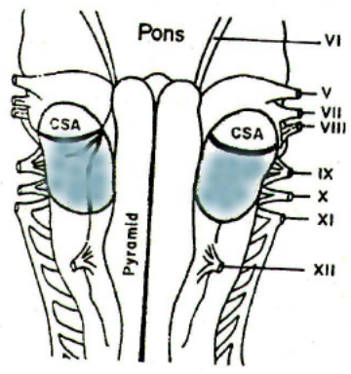
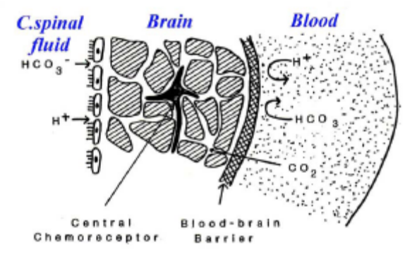
Summary
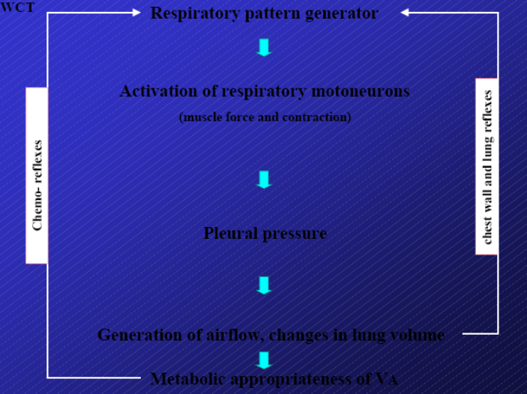
- The respiratory pattern generator eventually activates the respiratory motorneurons.
- The force generated by the muscles depends on the intrinsic properties of the muscles.
- They generate a pressure which translates into flow depending on the mechanics and characteristics of the system, called the equation of motion:
P_{total} = (Volume/Compliance) + (Flow x Resistance)
- All this is eventually controlled by chest wall afferents, which are actually more posturally-oriented in their integration of respiratory function.
- The lung reflexes act on a millisecond-to-millisecond basis to regulate the depth of breathing.
- Then, whether or not this is appropriate in terms of matching the metabolic rate and therefore achieving the right amount of blood gases is monitored by peripheral and central chemoreceptors.
- In addition to these two major types of feedback systems (neural and chemical), there are many other feedback systems that help to fine-tune the response according to need.

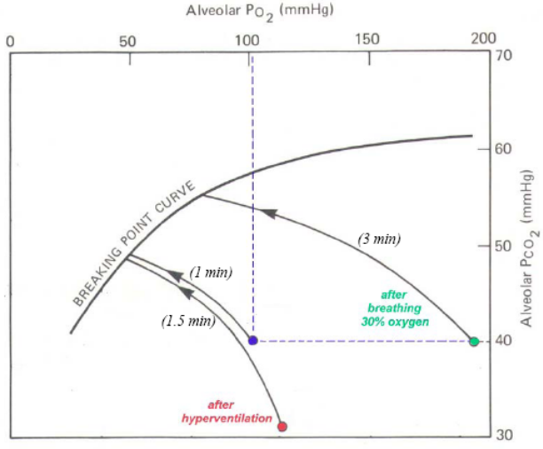
Holding Your Breath
- A subject was asked to hold their breath.
- It is expected that PO₂ will go down and PCO₂ will go up until the breaking point is reached (after 1 minute).
- The breaking point is an urge to breathe that we cannot overcome. Of course, we have a cortical will that we utilize to prevent ourselves from breathing, but this cannot overcome the breaking point.
- The chemical urge to breathe is far more powerful than any cortical input that can be sent to the respiratory centres.

- If this maneuver is repeated after hyperventilating, the PCO₂ will decrease. Therefore we are starting with a lower PCO₂ and a slightly higher PO₂.
- Because of this, it will take longer to reach the breaking point (1.5 minutes).
- From this, we might conclude that we have a critical PCO₂ and a critical PO₂ and that if they are reached, we are forced to breathe.

- However, what happens if we do this experiment after breathing oxygen?
- You would start with a normal PCO₂ and a higher PO₂.
- The breaking point (3 minutes) is at a substantially higher PCO₂ and PO₂ level than seen in the previous situations.
- In this case, the critical PO₂ was only 80 mmHg, whereas in the previous tests, the critical PO₂ was approximately 50 mmHg. This is a surprising result.

- Through further testing, it is found that there is no single breaking point. There is in fact a breaking point curve.
- This means that our drive to breathe is not related to PCO₂ and PO₂ alone. What is stimulating our breathing is lung collapse.
- Try to think of the maneuver:
  - You breathe in then hold your breath.
  - While you are holding your breath, your PO₂ decreases and PCO₂ increases.
  - Lung volume is also decreasing because you are using O₂ and returning only a small amount of CO₂ that does not match the amount of O₂ consumed. Your lung is shrinking.
  - This causes the stretch receptors to fire more and more to try and force you to breathe.
  - The shrinking of the lung creates such a large driving force to breathe, that even a relatively high PO₂ is not enough to stop breathing from occurring. For example, in the experiment where breath-holding was preceded by breathing O₂, the critical PO₂ was higher than those seen in the other experiments but was not enough to prevent breathing from occurring.
    - These results indicate that breathing is a coordinated response involving many inputs (vagus, lung volume, chemoreceptors, etc.) that are integrated in different ways according to circumstance.

Take Home Message: The breaking point curve gives the PO₂ and PCO₂ values at which breath-holding can no longer be maintained. These values will change depending on the circumstances, under which breath-holding is performed, such as whether the subject hyperventilated before holding their breath. It is due to the factors of PCO₂, PO₂ and most importantly, lung volume, combined that produce the breaking point curve.

Aquatic Mammals
- Why are animals so good at holding their breath?
- Think of aquatic mammals. Not only do they hold their breath for a longer period of time, but they also dive deep into the water.
- There have been documented cases where mammals dive as far as 0.5 km underwater.
- Every 10 m of water is equal 1 atm of pressure. If you want to go down 400 m, you are adding 40 atm of pressure to yourself for a total of 41 atm, compared to only 1 atm above water.
- At that high pressure, everything collapsible in your body will collapse by a pressure that is 40 times higher than what we normally have.

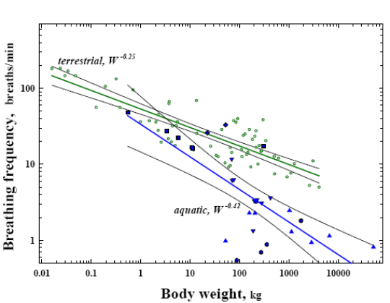
- How can these animals achieve such performances? Can we learn anything from them about regulating breathing?
- First of all, they breathe slowly and deeply when they are at the surface of the water (for example, the breathing frequency of a whale can be substantially less than one breath per minute but it is very deep).
- Therefore they breathe a lot, and then they exhale and dive.
- Does it make sense to exhale before diving? Yes, as we will see in a moment.
- The mammals breathe slowly with larger lung volumes because they have to stay afloat – they have to improve their buoyancy. If you have a large lung volume, you float because you have a decreased average density for your body.

- Another characteristic of these animals is to decrease metabolic rate. This is called the diving reflex.
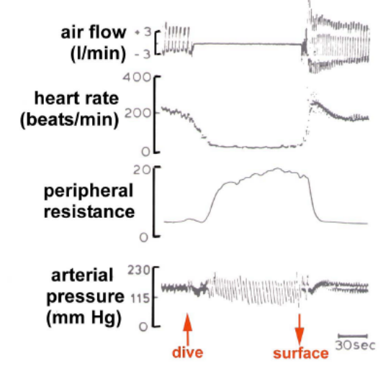
- We also had this reflex when we were babies.
  - If you spray water at a baby’s face, you may see this response.
  - They will stop breathing and heart rate will go down while peripheral resistance increases. Blood pressure will decrease slightly.
- An increase in peripheral resistance means that there is constriction of the blood vessels. This is done to bring the blood to the central, vital organs of the body, decreasing blood in the periphery.
- The diving reflex with bradycardia, hypotension and apnea are characteristic of animals that spend time underwater and also young mammals.
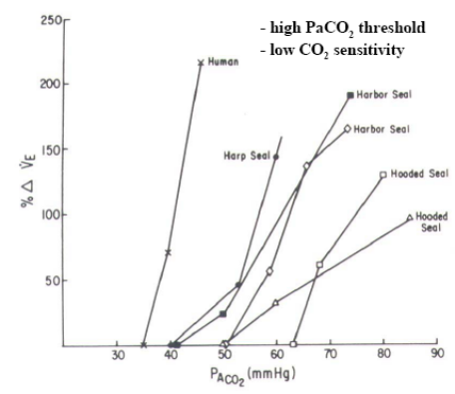
Chemosensitivity of Diving Mammals
- The graph to the right shows the sensitivity to hypercapnia.
- Animals that normally dive (seals, sea lions, etc) have a lower CO₂ sensitivity and a higher PaCO₂ threshold.
  - They try to delay the CO₂ stimulus to breathe.

- Why don’t these animals suffer like we do when we go underwater?

Diving Human
- Consider the diagram to the lower right (titled – pulmonary gas: oxygen). It shows an individual standing at the surface of a body of water. Their lungs are indicated by the blue triangle.
- If the individual tries to dive 90 m underwater, they will experience a pressure 9 atm above what we normally have at the surface (for a total of 10 atm).
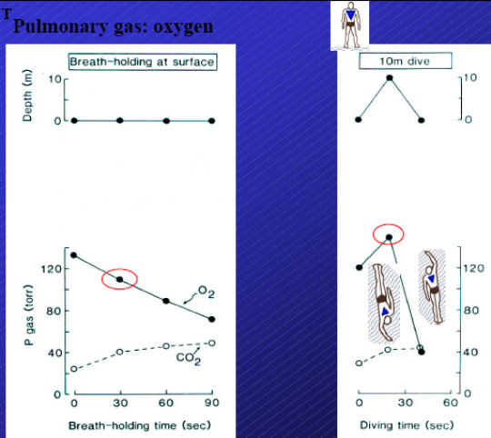
- Therefore you expect that collapsible areas (including the lungs) will be squeezed by a factor 10 times greater than that, which is felt at the surface.

- In the first case, the subject is at the surface (depth of zero), and they hold their breath for one minute, PO₂ decreases and PCO₂ increases.

- In the next test, the subject holds their breath while diving 10 m (equal to 1 atm).
- We expect that the subject’s lungs will shrink to half their original size, since the total pressure experienced by the subject is now 2 atm. The pressure has doubled therefore the volume should decrease by half (Boyle’s law: P₁V₁ = P₂V₂).
- PO₂ is actually increasing in this case. They are breath-holding so PO₂ should be decreasing. However, because they are diving, the lung is being squeezed thus increasing the partial pressure of the gas.
- The chemoreceptors will not fire because they sense an enormous amount of oxygen.

- Then the subject swims back to the surface and this is where the problems occur.
- The lungs expand all of a sudden and the pressures drop. The PO₂ plummets. The subject then feels an enormous urge to breathe. Eventually, they will try to breathe. This is known as blackout.
- This is extremely dangerous because there are no warning signs.

Characteristics of a Good “Free”-diver
- What are the tricks to being a good “free”-diver?
- First of all, you should try to decrease lung volume to a very low value. You can then avoid the compression and expansion, previously mentioned, that produces blackout. This is why animals exhale before they dive.
- Have abundant O₂ stores that are not in the lungs but in the muscles and blood, which is characteristic of diving animals.
- To have a high PCO₂ threshold and blunted sensitivity to CO₂ to delay the stimulus and urge to breathe.
- To have a strong diving reflex so that the blood will go to the key organs and will not be wasted in the periphery.

PHGY 312 – Lecture 34 April 2, 2007
Writer: Ana Coutinho Dr. Mortola

RESPIRATORY PHYSIOLOGY - VENTILATORY ACCLIMATIZATION AND HYPOXIA

I. REVIEW OF LAST LECTURE
- The ventilatory response to hypoxia
  - PaO₂-V_{E} – the ventilatory response to PaO₂
  - CaO₂-V_{E} – the ventilatory response to the saturation of content
    - It is important to note that these are not the same terms, due to the shape of the relationship. This may be affected by the relationship between the Hb-O₂ dissociation curve.
  - The response to hypoxia usually represented as a result of the content of saturation, if the data is available.
- The ventilatory response to hyperoxia
  - This condition is never faced in real life, unless it is imposed in clinical situations.
  - The only physiological context in which this occurs at birth. In the womb there is less O2 available; P_{a}O₂ is 40mmHg compared to 100mmHg. However, as soon as the baby is born, they are exposed to hyperoxia; there is flooding of O₂, This is potentially risky.
    - We will discuss this further when we talk about perinatal respiration.
- Hypoxic sensitivity and its dependence on CO₂
- Ventilatory response to hypercapnia (and its dependence on O₂)
  - Remember that the responses to hypoxia and hypercapnia interact in a multiplicative way.
- The P_{a}O₂ Threshold
  - This is the minimum P_{a}CO₂. Below this value, ventilation stops.
  - When measured, we can see it is only 4-5 Torrs below the normal value.
    - Therefore, we can see that it does not take much hyperventilation to move below threshold.
- Peripheral and Central Chemoreceptors
- Chemoreception: interaction with lung-volume (breath-holding)
  - The interaction between the lung and chemoreceptors works continuously, on a breath-by-breath basis.
  - The response of chemoreception to blood gases is a slow response. Think. Normally, upon expiration, the PO₂ decreases and the PCO₂ increases. When one holds their breath, these values are exaggerated
  - It takes several seconds before the chemoreceptors notice this change whereas the control of lung volume is dependent on stretch receptors, which are correlated on a millisecond basis.
  - The control of the breathing patterns during breath holding causes the frequency of breathing to become very rapid very quickly. However, the chemical control of breathing is far more flexible and allows for deviations.
  - This is useful. For example, as Prof. Mortola talks, he is ventilating more than he needs to, causing his PCO₂ to be lower than 40mmHg. It would be ridiculous if his chemoreceptors kept telling him that he needed to slow down his breathing rate. The elasticity of the chemoreceptor function allows greater deviations to take place without implementing control mechanisms, which is more convenient for functionality in the real world.
      - The stretch receptors are the main regulators of fine breathing pattern.
- Blood gases during breath-holding and diving
- What makes a good diver?

II. QUESTIONS AND ANSWERS
Correct answers are bolded.

The sensitivity of the hypoxic ventilatory response depends on?
- The mechanical properties of the respiratory system
  - Will play some factor due to the fact that it is a ventilatory response. Whenever we talk about ventilatory responses, mechanical properties always contribute. For example, a fibrotic patient, regardless of vagal input, would have low ventilation because the system has low compliance.
- The sensitivity of the vagal receptors
- This is incorrect because the vagus controls the stretch receptors, which have no effect on the hypoxic ventilatory response. This response is mainly dependent on chemoreceptors.
- Alveolar CO₂
- Central chemoreceptors
- Remember that this response is only sent peripherally, not centrally.
Note: Dr. Mortola only considered C to be the true answer, however he pointed out that A is also correct, to a certain extent. This would be a grey area answer.

During free diving, loss of consciousness can occur during ascent because of?
- The progressive rise in PCO₂ during breath holding
- This does not make sense. Although PCO₂ rises during breath holding, it helps brain circulation because it is a vasodilator in the brain. Therefore, if anything, you are more conscious, due to increased perfusion in this area.
- Loading PO₂ sensitivity to CO₂
- Hyperoxic hyperventilation
- In cases of hyperoxic ventilation before the dive, you will prolong your breath holding time.
- This was used as a trick in competition, but it is a dangerous thing to do. The subject is starting with a lung full of O₂ and is hyperventilating. Therefore, the chemoreceptors are completely silent and there is low CO₂ and very high O₂ present. The subject will have no warning that he is running out of gas. Therefore, when he eventually changes direction after there is a complete decrease in O₂, the activation of control mechanisms will force him to breathe.
- The drop in PO₂ as lung volume expands
- This is the most obvious answer. Upon descent, your lungs are squeezed and there is an increase in PO₂. Upon ascent, the opposite occurs, there is a dramatic decrease in PO₂ and you faint.

The extraordinary abilities of some mammals to breath-hold and dive are favoured by?
- Large volumes of air stored in the lung.
- We just discussed above why this is incorrect. In addition, large lung volumes also contain large quantities of nitrogen..
- Marked activity of the rapid-adaptive vagal receptors.
- This has nothing to do with the question.
- Low inspiratory sensitivity to CO₂
- This will prolong your breath holding time.
- Large oxygen stores in muscle and blood.
- This is true. This oxygen is stored in the blood bound to haemoglobin and in the muscles bound to myoglobin. This is how animals, such as sea lions, can have long dives.
- This effect also contributes to a blunted response to hypercapnia, due to lower sensitivity of the chemoreceptors. However, they have a higher pressure, so they not only have a delayed response to CO₂, but when they do respond, they respond with lower ventilation.
Question From a Student
Why can’t we improve breath-holding time?
- We can, with extended training. Therefore, to an extent we can all become better divers, but there will always be some individuals, that through evolution, will be better divers than others.
- In addition, we can also improve our PCO₂ threshold and blunted sensitivity to CO₂. This will help improve our breath holding time to a small extent.
Why is it possible to improve breath-holding time?
- When we hold out breath for a long time, it is usually the pain felt that causes us to breathe again. Just like anything else that causes pain, we can learn to suppress it, and thus extend out breath-holding time.
- The threshold response to CO₂ can also, to some extent, be painful. It has been shown that elite divers have a blunted response to pain, similar to that of sea lions.
- However, these reasons are controversial. Some say that these individuals (good divers) were just born this way and that training had nothing to do with it.
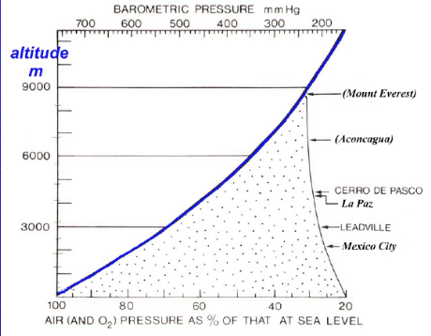
III. HIGH ALTITUDE HYPOXIA
- We have already learnt about hypoxia and high altitude separately.
- High altitude is considered to be anything over 3000 meters. There are a surprising amount of areas that surpass this altitude and they have a total of over 30 million people living in them.
- As altitude increases, barometric pressure drops. However, it does not occur in a linear fashion; it fits the relationship according to the graph on the right, which can be described as curvilinear. Essentially, the air becomes progressively thinner as the altitude increases.
  - At approximately 3000m, the barometric pressure is approximately 70% of the sea level pressure, which leads to a total of 15% O₂.
- If you ask a hospital for permission to expose a baby to these hypoxic conditions found at high altitudes, they will refuse to do so. However, consider the fact that every day babies are being born in these hypoxic, high altitude areas and they survive. What allows these individuals to live at high altitudes?
- In some places at 3000m, there is only snow. However, we must also factor in latitude to the altitude. Therefore, there are many places that have liveable conditions. Consider cities in South America, such as La Paz and Cerro de Pasco.

- Illustrated below and as we have already seen, breathing oscillations take place with body temperature in normoxia.
- We can see that in hypoxia, these oscillations are very small. (Disregard the drop in the graph, which signals acute hypoxia). These oscillations are crucial for determining many aspects of our life; physiological and behavioural
- It is possible that the effects of hypoxia on the circadian patterns at body temperatures could influence our responses to ventilation at high altitudes.
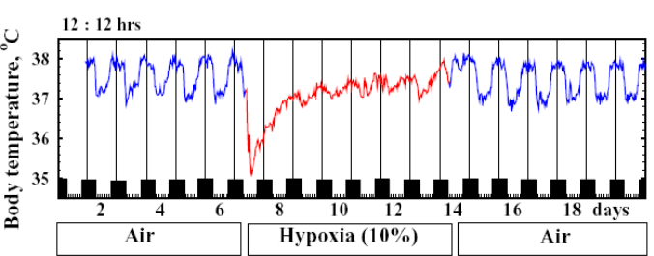
  - Whe you move to hypoxic conditions it is very difficult for an individual to sleep or even eat for the first couple of days. Part of these disturbances could be due to the effect of hypoxia on the circadian rhythms.

PO₂ – PCO₂ Graph and the Sensitivity to Hypoxia:
- At sea level, we have a PaO₂ of 100mmHg and a PCO₂ of 40mmHg.
- If exposed to high altitudes and thus hypoxia, PO₂ drops more than 60 Torr and you increase your ventilation. This blows off CO₂ and also increases the PO₂ in the alveoli.
- Therefore, PCO₂ decreases a little (this is the definition of hyperventilation), but PO₂ increases.
Note below that the slope of the curve has changed in the PO₂-PCO₂ graph (see graph below).

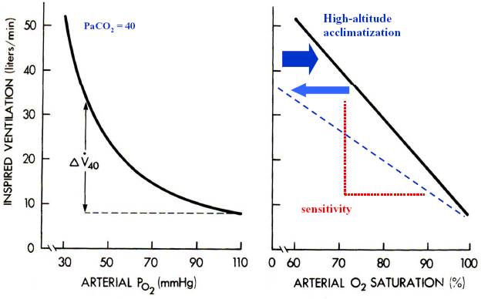
- If you remain in hypoxic conditions, the ventilation increases quite a bit. This is called ventilatory acclimatization, the re-establishment of a normal CO₂/HCO₃⁻ ratio.
- This implies that PCO₂ will decrease even more, but at the same time, PO₂ get slightly higher.
  - The increase in PO₂, even a few Torr will make a large increase in the amount of O₂ the haemoglobin can trap. The most important thing is that even the small amount of change in PO₂ makes a huge difference on the ventilatory response.

But what provokes acclimatization?
- There are two main mechanisms:

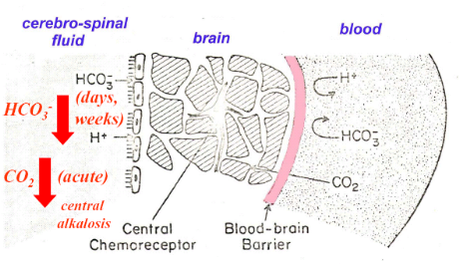
- When we increase ventilation with hypoxia, the increase depends on PCO₂ and PCO₂ will decrease, due to the fact that you are hyperventilating. This determines our sensitivity to hypoxia.
- Recall that the chemoreceptors do not measure PCO₂, but pH. Over time, even though PCO₂ will remain low, pH is corrected for by the elimination of bicarbonate.
- This causes the ventilatory response to hypoxia to rise again, although PCO₂ remains low. Therefore, the subject is hyperventilating

- Note the cross-section of the central chemoreceptor (above right). The receptors are separated from the blood via the blood-brain barrier.
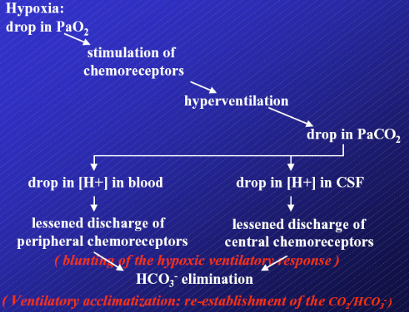
- We already know that CO₂ can diffuse much easier than bicarbonate across this barrier. This means that if CO₂ decreases, it decreases in the blood, affecting peripheral chemoreceptors and in the brain, affecting central chemoreceptors,
  - There is alkalosis on both levels. The increasing pH will be corrected, but it takes time for the bicarbonate to move across the barriers to be eliminated.
  - However, once the bicarbonate concentrations decrease, there is no longer the initial blunting of the ventilatory response.
  - This method is essentially used for the re-establishment of normal pH. Note the summary slide to the right.
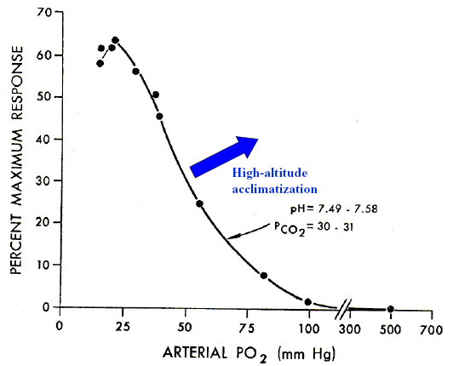
- Increases in the sensitivity of the peripheral chemoreceptors according to PaO₂. For any given PO₂, the chemoreceptor will fire more to increase the activity of the ventilatory response. However, this response takes time to kick in.
Recall he graph to the right. It illustrates the PO₂ in relation to the response of the carotid sinus body.

Take Home Message: There are two responses that are involved in acclimatization; the response of the central chemoreceptors and the response of the peripheral chemoreceptors.
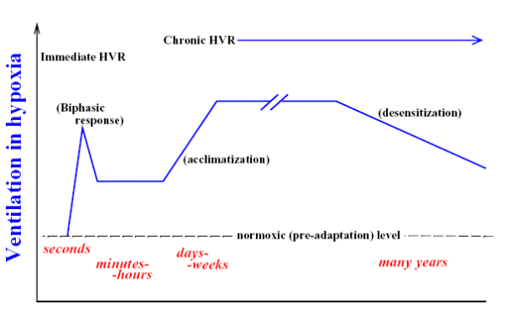
Ventilation in Hypoxia over Time:
- When we are suddenly exposed to hypoxia, our ventilation increases.

Note: Ignore the spike you see, we did not discuss this. It has to do with the fact that the carotid bodies notice this change first and adapt. The most important thing is the process of alkalosis. In addition, there is a small drop in metabolism. Either way, this is a transient acute response.

- If you remain in hypoxic conditions, there is acclimatization, according to the two mechanisms we just described: decrease in pH and increase in the sensitivity of the chemoreceptors.
- Remember that ventilation makes the difference between the amount of O₂ we would like to have in our muscles and what we actually have in them.
  - Mountain climbers, once they got close to the top, they use to put their hands in front of their mouths to their rebreathe their exhalations. This is advantageous because they rebreathe in the CO₂, which acts as a vasodilator. Thus, when they take their next breath, the efficiency of ventilation increases.
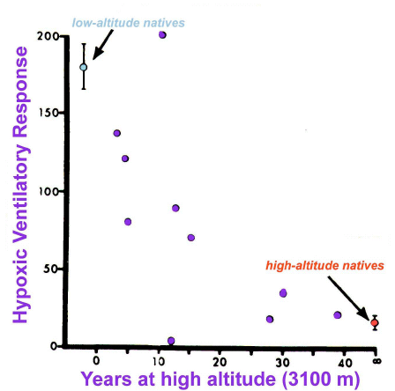
- After days or weeks [at least a month] or years, you eventually decrease ventilation through a process known as deacclimatization or desensitization.
- This process occurs over time and we just begin to breathe less and less. In the end, the subject is still hyperventilating, but it is much more reduced than prior to desensitization.
- The graph to the left shows the process of a low-altitude native being subjected to high altitude and the compensatory response the subject undergoes. To compare, notice how the high-altitude native’s ventilatory response is already quite low. It takes the low-altitude subject more than 30 years to reach this level.

Why do the high-altitude subjects not need to breathe as fast?
- Recall that Oxygen used = oxygen delivered – oxygen extraction. This is the Fick Equation applied to the respiratory system.
- These subjects use exploit extraction; they can make much better use of the O₂ transported than subjects living at lower levels.
- They can do this through:
  - An increase in capillaries in the muscles
  - Changes in haemoglobin
  - Increased level of RBCs concentration, up to 70%
    - This can be dangerous, due to the increased afterload on the heart, due to the increased viscosity of the blood.

- When we are at hypoxia we can either increase ventilation, alter extraction (but this requires a structural change in both the respiratory and cardiovascular system), or we can drop the metabolic rate.
- Dropping the metabolic rate when you are hypoxia can lead to a situation where we don’t need to ventilate at all, since there is no O₂ being used. This is the most common solution in all animals. There are only a few exceptions: adult birds and adult mammals.
- However, even in adult mammals, one can choose to drop metabolic rate, even if it does not occur naturally

- Consider this: if the concentration of O₂ dropped in this room, one would become very agitated. Your options to compensate include:
- Increasing ventilation
- This is silly because the air supply is limited, so in the end, you would just be wasting the O₂ that you have.
- Dropping O₂ consumption and waiting for conditions to get better.
  - This is the option usually chosen and it is what we all did as newborns.

- However, if we drop metabolic rate, we have to give up some functions. These functions include:
  - A decreased sensitivity in cells. We become hypotonic and we lose muscle control
  - A decrease in heat control, so we become cold
  - A blunted growth rate. Therefore hypoxic animals grow less, but they are still alive.
    - As adults, we have lost the ability to do this. This is why if an adult and a newborn are put in the same conditions, the newborn will surpass the existence of the adult.

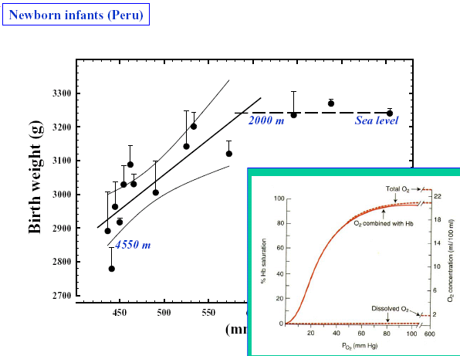
- Upon studying of babies at various altitudes, you can find that up to 2000 meters, the birth weight is unaffected. After this point, weight begins to decrease, approximately 60g every 500m. This is the immediate effect of what we have just discussed; they have given up growth. This is hypoxia in utero.
- However, this blunted growth occurs even after birth if the conditions remain hypoxic.
- Note the Hb-dissociation curve to the right. Up to a given altitude, growth is not disturbed because the mother can provide for the fetus and the high affinity of fetal Hb helps, but after a certain point, the PO₂ drops in the mother, the placenta, and therefore the fetus. This causes retardation of growth.

Consider two twin rats: one grew in normoxia and one in hypoxia.
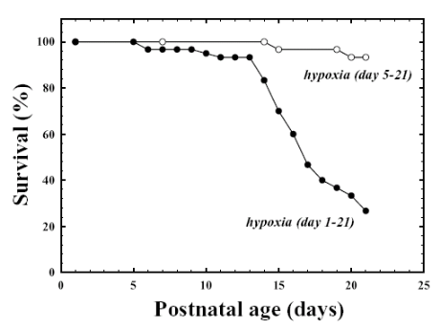
- When you have a decrease in metabolic rate to save in growth, you do not do this homogenously. Some of your organs need more O₂ than others. For example, the brain and heart need more than your bone and gut. This can result in the damage of certain organs over others and possibly death, depending on the extremes of the conditions.
- The graph to the left shows survival as a function of postnatal age. If the hypoxia is induced at day one, the rat has a much large chance of dying than compared to the rat where hypoxia was induced at day 5.

What if we stop the hypoxia? Would the animal catch-up?
- The results would be the equivalent of sionotic heart disease; the blood will bypass the lungs due to the creation of a shunt.
- If the hypoxia continues, the problems are drastic.
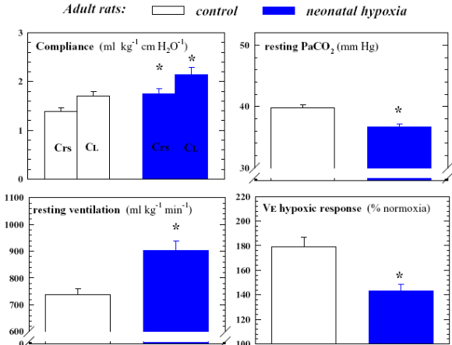
- If we stop the hypoxia at about one week, the foetus will catch-up in body weight within three weeks. The results show that females will do this better than males

Are the rats normal in terms of the respiratory system?
Note the graphs to the right, which study these rats as adults.
- The compliance has increased, both in the lungs and in the respiratory system as a whole. The graph is corrected for weight, so they also have bigger lungs.
- They ventilate more at rest and have a slightly smaller PCO₂. This is the same as seen in highlanders.
- If we expose the rats to a new episode of hypoxia, they respond less.

Conclusion:
- Neonatal hypoxia has long-term effects on the neonatal respiratory system even when body weight is accounted for.
- Some of the characteristics that we see in the highlanders can be mimicked on lowland as long as the exposure occurs very early in life.

